30
Safeguarding Children

1.4 Confidentiality and client access to records

Policy statement

Definition: ‘Confidential information is information of some sensitivity, which is not already lawfully in the public domain or readily available from another public source, and which has been shared in a relationship where the person giving the information understood it would not be shared with others.’ (Information Sharing: Practitioners’ Guide)

In Burghclere Pre-school, staff and managers can be said to have a ‘confidential relationship’ with families. It is our intention to respect the privacy of children and their parents and carers, while ensuring that they access high quality early years care and education in our setting. Burghclere Pre-School aims to ensure that all parents and carers can share information in the confidence that it will only be used to enhance the welfare of their children. There are record keeping systems in place that meet legal requirements; means of storing and sharing that information take’s place within the framework of the Data Protection Act and the Human Rights Act.

EYFS key themes and commitments

A Unique Child | Positive Relationships | Enabling Environments | Learning and Development
1.3 Keeping safe | 2.1 Respecting each other  2.2 Parents as partners | 3.4 The wider context

Confidentiality procedures

- Burghclere Pre-School will always check whether the information that parents/carers share with us is to be regarded as confidential or not.
- Some Parents/carers will sometimes share information about themselves with other parents/carers on the pre school premises. Burghclere Pre-School cannot be held responsible if information is shared beyond those parents whom the person has ‘confided’ in.
- Information shared between parents in a discussion or training group is usually bound by a shared agreement that the information is confidential to the group and not discussed outside of it.
- Burghclere Pre-School will inform parents when staff need to record confidential information beyond the general personal information staff keep (see our record keeping procedures) - for example with regard to any injuries, concerns or changes in relation to the child or the family, any discussions with parents on sensitive matters, any records staff are obliged to keep regarding action taken in respect of child protection and any contact and correspondence with external agencies in relation to their child.
- Burghclere Pre-School keep all records securely (see our record keeping procedures).

Client access to records procedures

Parents may request access to any confidential records held on their child and family following the procedures below:
- Any request to see the child’s personal file by a parent or person with parental responsibility must be made in writing to the Burghclere Pre-School manager.
- The Burghclere Pre-school manager will inform the chairperson of the management committee and send a written acknowledgement.
- Burghclere Pre-School commits to providing access within 14 days, although this may be extended.
- Burghclere Pre-School’s manager and chairperson of the management committee will prepare the file for viewing.
- All third parties are written to, stating that a request for disclosure has been received and asking for their permission to disclose to the person requesting it. Copies of these letters are retained on file.
- ‘Third parties’ include all family members who may be referred to in the records.
- It also includes workers from any other agency, including social services, the health authority, etc. It is usual for agencies to refuse consent to disclose, preferring the individual to go directly to them.
- When all the consents/refusals to disclose have been received these will be attached to the copy of the request letter.
- A photocopy of the complete file will be taken.
- The Burghclere Pre-School manager and chairperson of the management committee will go through the file and remove any information which a third party has refused consent to disclose. This is best done with a thick black marker, to score through every reference to the third party and information they have added to the file.
- What remains is the information recorded by Burghclere Pre-School, detailing the work initiated and followed by them in relation to confidential matters. This is called the ‘clean copy’.
- The ‘clean copy’ is photocopied for the parents who are then invited in to discuss the contents. The file should never be given straight over, but should be gone through by the manager, so that it can be explained.
- Legal advice may be sought before sharing a file, especially where the parent has possible grounds for litigation against Burghclere Pre-School or another (third party) agency.

All the undertakings above are subject to the paramount commitment of Burghclere Pre-School, which is to the safety and well-being of the child. Please see also our policy on child protection.

Legal framework

- Data Protection Act 1998
- Human Rights Act 1998

Further guidance

- Information Sharing: Practitioners’ Guide (HMG 2006)
www.everychildmatters.gov.uk/_files/ACB1BA35C20D4C42A1FE6F9133A7C614.pdf

This policy was adopted at a meeting of | Burghclere Pre School | name of setting
Held on | 25th March 2021 | (date)
Date to be reviewed | April 2022 | (date)
Signed on behalf of the management committee | 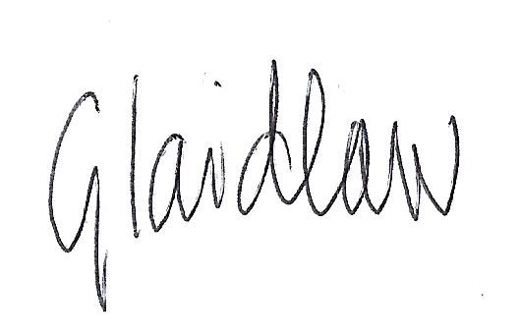
Name of signatory | Gemma Laidlaw
Role of signatory (e.g. chair/owner) | Chair

