Safeguarding children

1.8 Supervision of children on outings and visits

Policy statement

Children benefit from being taken out of the setting to go on visits or trips to local parks or other suitable venues for activities which enhance their learning experiences. Staff in Burghclere Pre-School ensure that there are procedures to keep children safe on outings; all staff and volunteers are aware of and follow the procedures below.

EYFS key themes and commitments

A Unique Child | Positive Relationships | Enabling Environments | Learning and Development
1.3 Keeping safe  1.4 Health and well-being | 2.2 Parents as partners | 3.3 The learning environment | 4.2 Active learning

Procedures

- Parents sign a general consent on registration for their children to be taken out as a part of the daily activities of the setting.
- This general consent details the venues used for daily activities.
- There is a risk assessment for each venue carried out, which is reviewed regularly.
- A risk assessment is carried out before an outing takes place.
- All venue risk assessments are made available for parents to see.
- Our adult to child ratio is high, normally one adult to four children, depending on their age, sensibility and type of venue as well as how it is to be reached.
- Named children are assigned to individual staff to ensure each child is individually supervised, to ensure no child goes astray, and that there is no unauthorised access to children.
- Outings are recorded in an outings record book kept in the setting stating:
- The date and time of outing.
- The venue and mode of transport.
- Names of staff assigned to named children.
- Time of return.
- Staff take a mobile phone on outings, and supplies of tissues, wipes, pants etc as well as a mini first aid pack, snacks and water. The amount of equipment will vary and be consistent with the venue and the number of children as well as how long they will be out for. Staff will ensure they have prescription medication and treatment plans for their assigned children.
- Staff take a list of children with them with contact numbers of parents/carers.
- Records are kept of the vehicles used to transport children, with named drivers and appropriate insurance cover.
- A minimum of two staff should accompany children on outings and a minimum of two should remain behind with the rest of the children.

This policy was adopted at a meeting of | Burghclere Preschool | name of setting
Held on | 25th March 2021 | (date)
Date to be reviewed | April 2022 | (date)
Signed on behalf of the management committee | 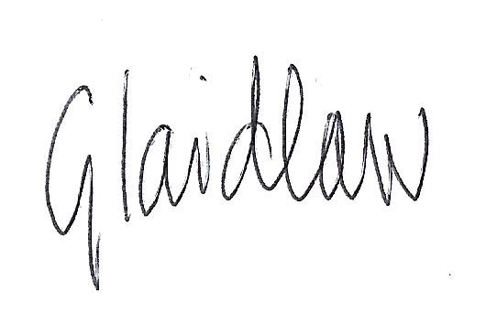
Name of signatory | Gemma Laidlaw
Role of signatory (e.g. chair/owner) | Chair

Other useful Early years Learning Alliance publications:

- Register and Outings Record (2006) Daily Register and Outings Record | Publications and resources for the early years | Pre-school Learning Alliance
- Risk Management in Early Years Settings (2007) http://www.playengland.org.uk/media/120462/managing-risk-play-safety-forum.pdf

