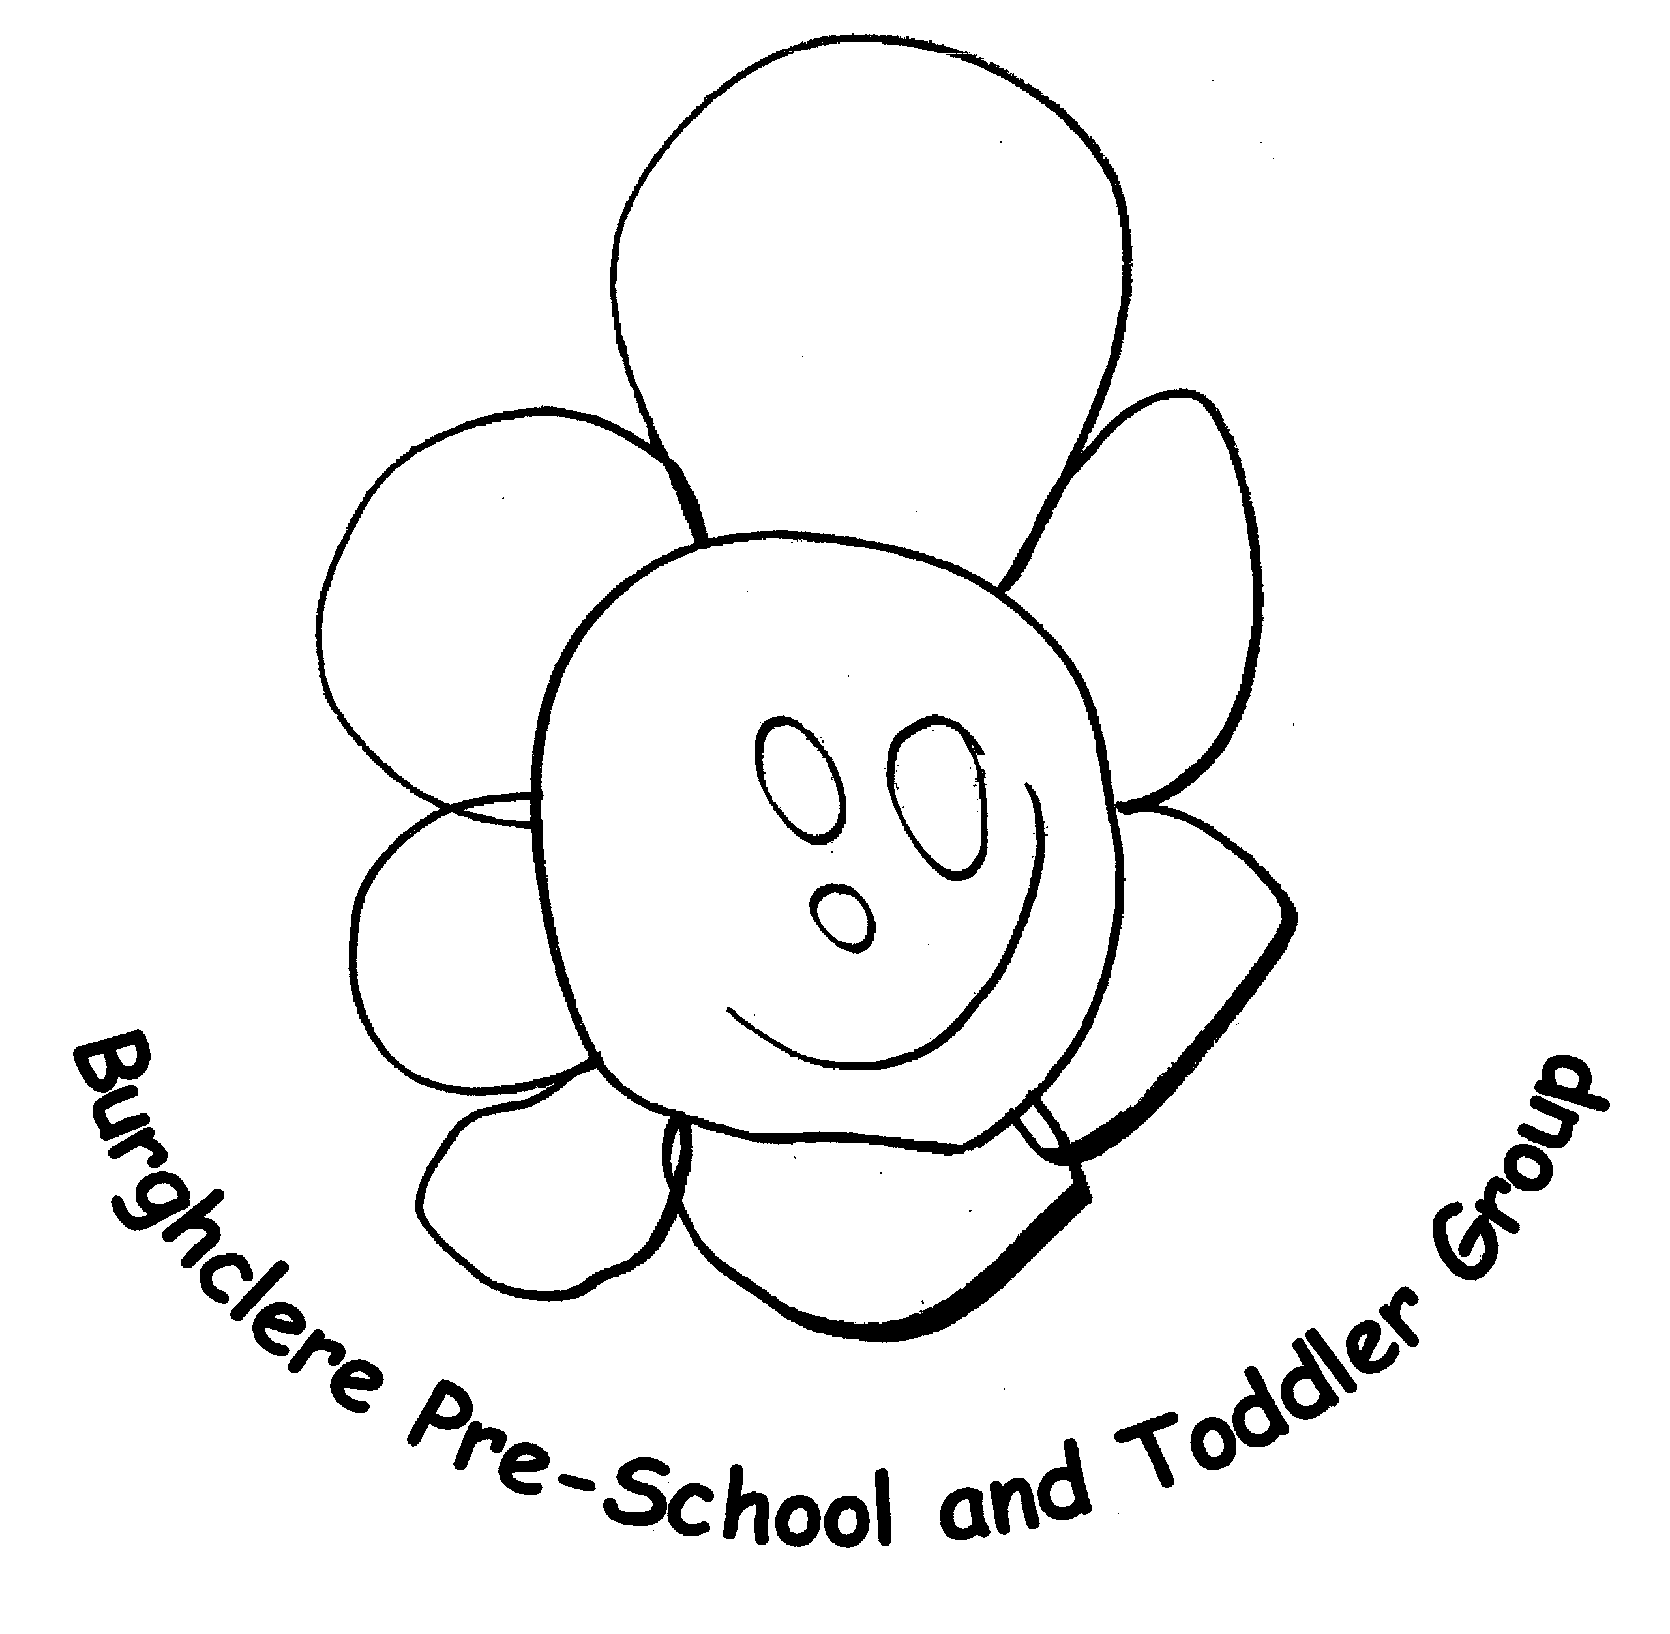
AFTER SCHOOL CLUB - ENROLEMENT FORM
The AFTER SCHOOL CLUB is registered to take children from YEAR 1 – YEAR 6
Please complete one form per child

Child’s Name

Date of Birth
Address inc. postcode

Contact e-mail address

Home telephone

Parent or guardian name(s), relationship to child and mobile number | Contact 1 | Contact 2
Emergency contact person name
Emergency person relationship to child
Emergency person contact number

In accordance to our policy, we are unable to refund any fees paid if we have to close due to an emergency.

AFTER SCHOOL CLUB – MEDICAL QUESTIONNAIRE
Please complete one form per child

Child’s Name

Date of Birth

Address inc. postcode

Does your child have any allergies? Yes No

If YES please specify

Does your child have a medical condition(s)? Yes No

If YES please specify

If your child may require any medication administering during their time at the after school club (i.e. inhales, anti- histamine, etc) please discuss directly with the after school club manager Juliann Heaver.

DOCTORS NAME:

SURGERY:

SURGERY ADDRESS:
DOCTOR PHONE:
Please return this form to the address above or hand to a member or member of staff at pre school.

