Safeguarding Children

1.6 Uncollected child

Policy statement

In the event that a child is not collected by an authorised adult at the end of a session/day, Burghclere Pre-School puts into practice the following agreed procedures. These ensure the child is cared for safely by an experienced and qualified practitioner who is known to the child. Burghclere Pre-School will ensure that the child receives a high standard of care in order to cause as little distress as possible.

Burghclere Pre-School inform parents/carers of our procedures so that, if they are unavoidably delayed, they will be reassured that their children will be properly cared for.

EYFS key themes and commitments

A Unique Child | Positive Relationships | Enabling Environments | Learning and Development
1.3 Keeping safe  1.4 Health and well-being | 2.2 Parents as partners | 3.4 The wider context

Procedures

- Parents of children starting at the setting are asked to provide the following specific information which is recorded on our Registration Form:
- Home address and telephone number - if the parents do not have a telephone, an alternative number must be given, perhaps a neighbour or close relative.
- Place of work, address and telephone number (if applicable).
- Mobile telephone number (if applicable).
- Names, addresses, telephone numbers and signatures of adults who are authorised by the parents to collect their child from the setting, for example a childminder or grandparent.
- Whoever has parental responsibility for the child.
- Information about any person who does not have legal access to the child.
- On occasions when parents are aware that they will not be at home or in their usual place of work, they inform us in writing of how they can be contacted.
- On occasions when parents or the persons normally authorised to collect the child are not able to collect the child, they provide us with verbal or written details of the name, address and telephone number of the person who will be collecting their child. Burghclere Pre-School agrees with parents how to verify the identity of the person who is to collect their child.
- Parents are informed that if they are not able to collect the child as planned, they must inform staff so that Burghclere Pre-School can begin to take back-up measures. Burghclere Pre-School provides parents with full contact details for this purpose.
- Burghclere Pre-School informs parents that we apply our child protection procedures as set out in our child protection policy in the event that their children are not collected from setting by an authorised adult within one hour after the setting has closed and the staff can no longer supervise the child on our premises.
- If a child is not collected at the end of the session/day,
Burghclere Pre-School follow the following procedures:
- The child’s file is checked for any information about changes to the normal collection routines.
- If no information is available, parents/carers are contacted at home or at work.
- If this is unsuccessful, the adults who are authorised by the parents to collect their child from the setting - and whose telephone numbers are recorded on the Registration Form - are contacted.
- All reasonable attempts are made to contact the parents or nominated carers.
- The child does not leave the premises with anyone other than those named on the Registration Form or in their file.
- If no-one collects the child after one hour and there is no-one who can be contacted to collect the child, Burghclere Pre-School apply the procedures for uncollected children.
- Burghclere Pre-School contact our local authority children’s social services care team:
0300 555 1384 | (telephone number)

For full day care, this will be the out of hours duty officer:
0300 555 1384 | (telephone number)

- The child stays at the setting in the care of two fully-vetted workers until the child is safely collected either by the parents or by a social care worker.
- Social Care will aim to find the parent or relative if they are unable to do so, the child will become looked after by the local authority.
- Under no circumstances do staff go to look for the parent, nor do they take the child home with them.
- A full written report of the incident is recorded in the child’s file.
- Depending on circumstances, Burghclere Pre-School reserves the right to charge parents for the additional hours worked by our staff.
- Ofsted may be informed:
0300 123 1231 | (telephone number)

- Our local Pre-school Learning Alliance office/Pre-school Development Worker may also be informed.
0207 697 2500 | (name and telephone number)

This policy was adopted at a meeting of | Burghclere preschool | name of setting
Held on | 25th March 2021 | (date)
Date to be reviewed | April 2022 | (date)
Signed on behalf of the management committee | 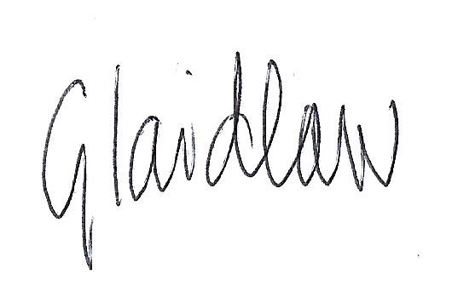
Name of signatory | Gemma Laidlaw
Role of signatory (e.g. chair/owner) | Chair

Other useful Pre-school Learning Alliance publications:

- Child Protection Record (2007)

