Safeguarding children

1.7 Missing child

Policy statement

Children’s safety is maintained as the highest priority at all times both on and off premises. Every attempt is made through carrying out the outings procedure and the exit/entrance procedure to ensure the security of children is maintained at all times. In the unlikely event of a child going missing, our missing child procedure is followed.

EYFS key themes and commitments

A Unique Child | Positive Relationships | Enabling Environments | Learning and Development
1.3 Keeping safe  1.4 Health and well-being | 2.2 Parents as partners | 3.4 The wider context

Procedures

Child going missing on the premises
- As soon as it is noticed that a child is missing the key person/staff alerts the setting manager.
- The manager will carry out a thorough search of the building and garden.
- The register is checked to make sure no other child has also gone astray.
- Doors and gates are checked to see if there has been a breach of security whereby a child could wander out.
- If the child is not found, the parent is contacted and the missing child is reported to the police.
- The manager talks to the staff to find out when and where the child was last seen and records this.
- The manager contacts the chairperson and reports the incident. The chairperson may come to the setting immediately.
- The chairperson, with the management committee, will carry out a thorough investigation in respect of this event preventing its occurrence in the future.

Child going missing on an outing

- As soon as it is noticed that a child is missing, staff on the outing ask children to stand with their designated person and carry out a headcount to ensure that no other child has gone astray. One staff member searches the immediate vicinity but does not search beyond that.
- The manager is contacted immediately and the incident is reported.
- The manager contacts the police and reports the child as missing.
- The manager contacts the parent, who makes their way to the setting or outing venue as agreed with the manager. The setting is advised as the best place, as by the time the parent arrives, the child may have been returned to the setting.
- Staff take the remaining children back to the setting.
- In an indoor venue, the staff contact the venue’s security who will handle the search and contact the police if the child is not found.
- The manager contacts the chairperson and reports the incident. The chairperson, with the management committee carries out an investigation and may come to the setting immediately.
- The manager, or designated staff member may be advised by the police to stay at the venue until they arrive.

The investigation
- Staff keep calm and do not let the other children become anxious or worried.
- The manager together with the chairperson or representative from the management committee speaks with the parent(s).
- The chairperson and management committee, carry out a full investigation taking written statements from all the staff in the room or who were on the outing.
- The key person/staff member writes an incident report detailing:
- The date and time of the report.
- What staff/children were in the group/outing and the name of the staff designated responsible for the missing child.
- When the child was last seen in the group/outing.
- What has taken place in the group or outing since the child went missing.
- The time it is estimated that the child went missing.
- A conclusion is drawn as to how the breach of security happened.
- If the incident warrants a police investigation, all staff cooperate fully. In this case, the police will handle all aspects of the investigation, including interviewing staff. Children’s Social Care may be involved if it seems likely that there is a child protection issue to address.
- The incident is reported under RIDDOR arrangements (see the Reporting of Accidents and Incidents policy http://www.hse.gov.uk/riddor); the local authority Health and Safety Officer may want to investigate and will decide if there is a case for prosecution.
- In the event of disciplinary action needing to be taken, Ofsted is informed.
- The insurance provider is informed.

Managing people
- Missing child incidents are very worrying for all concerned. Part of managing the incident is to try to keep everyone as calm as possible.
- The staff will feel worried about the child, especially the key person or the designated carer responsible for the safety of that child for the outing. They may blame themselves and their feelings of anxiety and distress will rise as the length of time the child is missing increases.
- Staff may be the understandable target of parental anger and they may be afraid. Setting leaders need to ensure that staff under investigation are not only fairly treated but receive support while feeling vulnerable.
- The parents will feel angry, and fraught. They may want to blame staff and may single out one staff member over others; they may direct their anger at the setting leader. When dealing with a distraught and angry parent, there should always be two members of staff, one of whom is the setting leader and the other should be the chairperson of the management committee or representative, or the proprietor. No matter how understandable the parent’s anger may be, aggression or threats against staff are not tolerated, and the police should be called.
- The other children are also sensitive to what is going on around them. They too may be worried. The remaining staff caring for them need to be focused on their needs and must not discuss the incident in front of them. They should answer children’s questions honestly but also reassure them.
- In accordance with the severity of the final outcome, staff may need counselling and support. If a child is not found, or is injured, or worse, this will be a very difficult time. The chairperson will use their discretion to decide what action to take.
- Staff must not discuss any missing child incident with the press.

This policy was adopted at a meeting of | Burghclere Preschool | name of setting
Held on | 25th March 2021 | (date)
Date to be reviewed | April 2022 | (date)
Signed on behalf of the management committee | 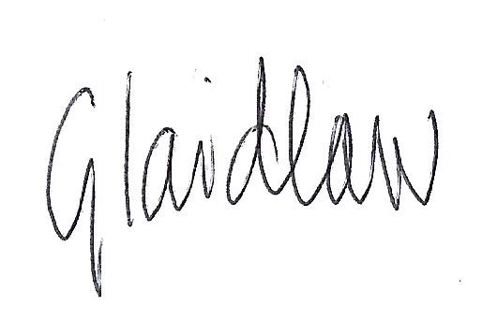
Name of signatory | Gemma Laidlaw
Role of signatory (e.g. chair/owner) | Chair

